Name : MUHAMMAD MUBASHAR ALI
Student ID : BSIET02213012
Subject: Object Oriented Programming
Lab : 12

Example # 01

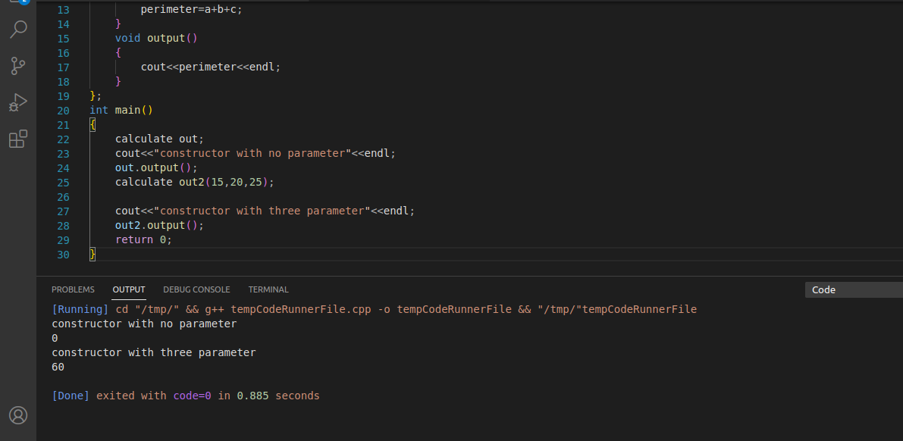

Example # 02

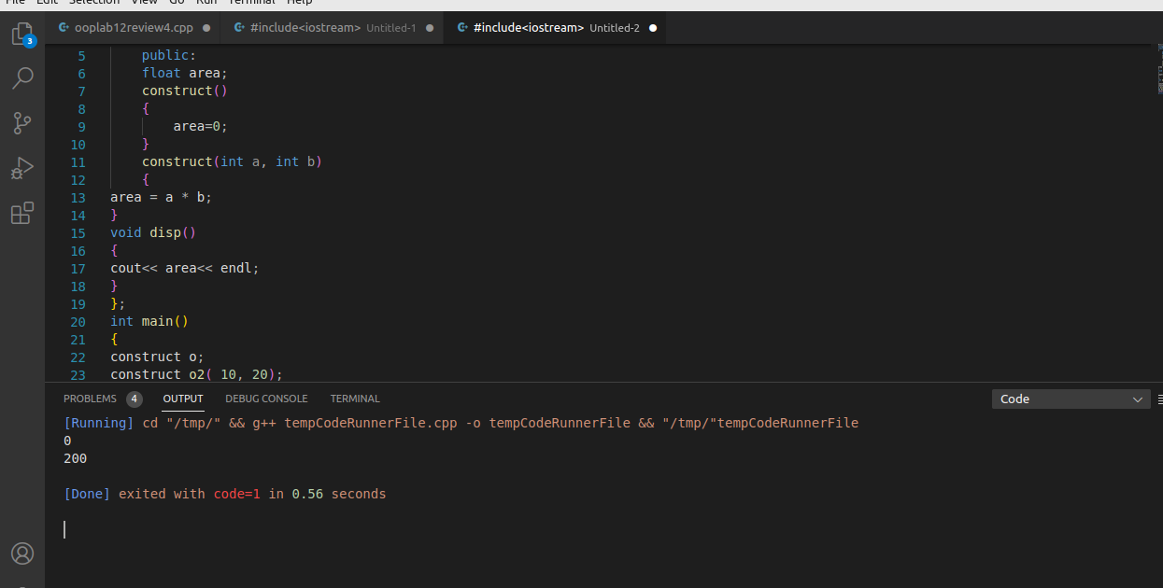
Example # 03

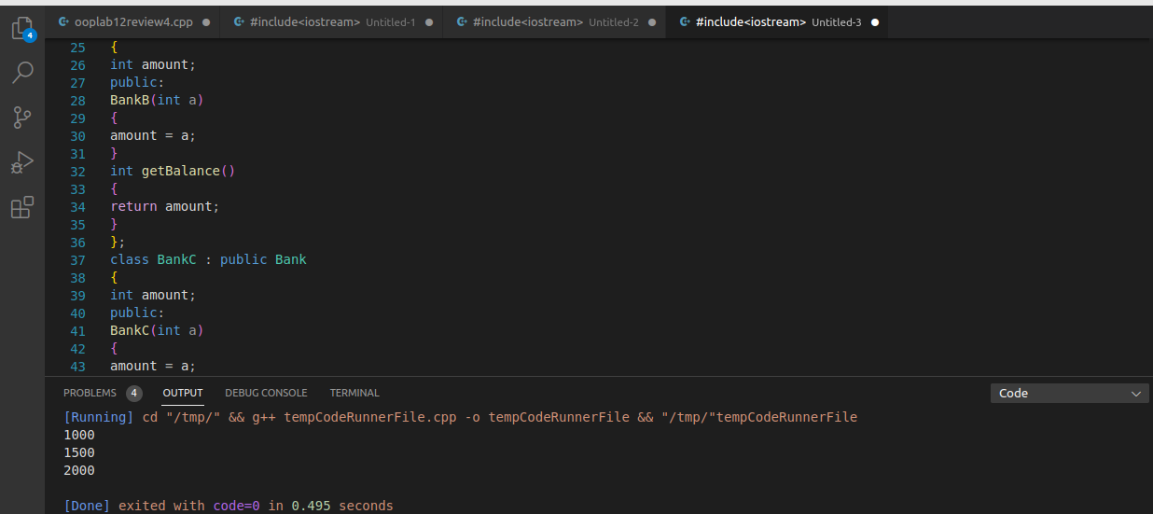
Example # 04
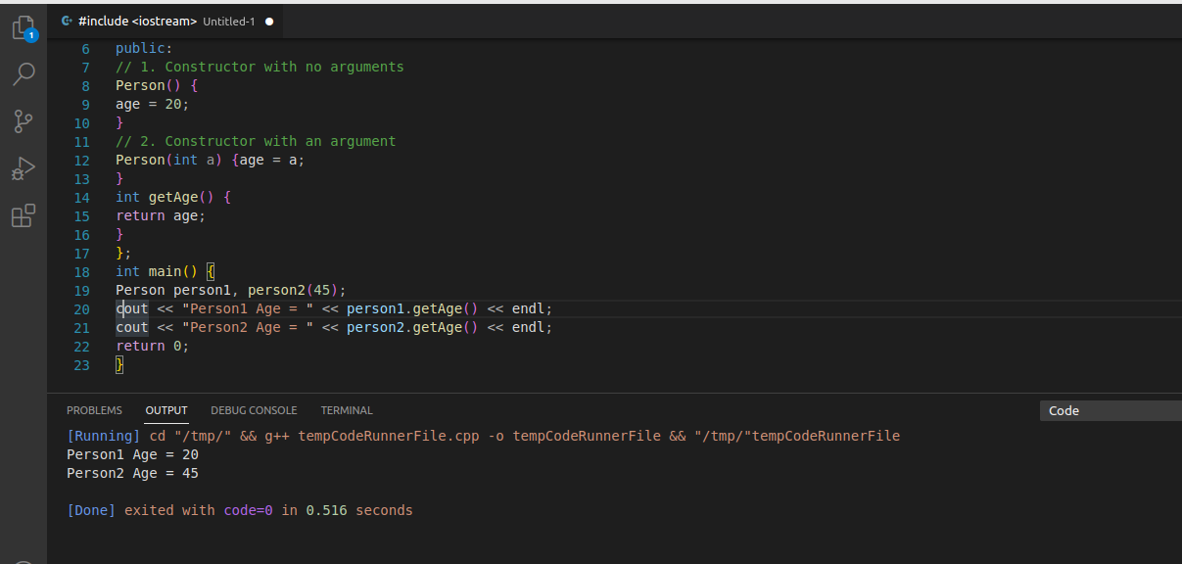

Example # 05

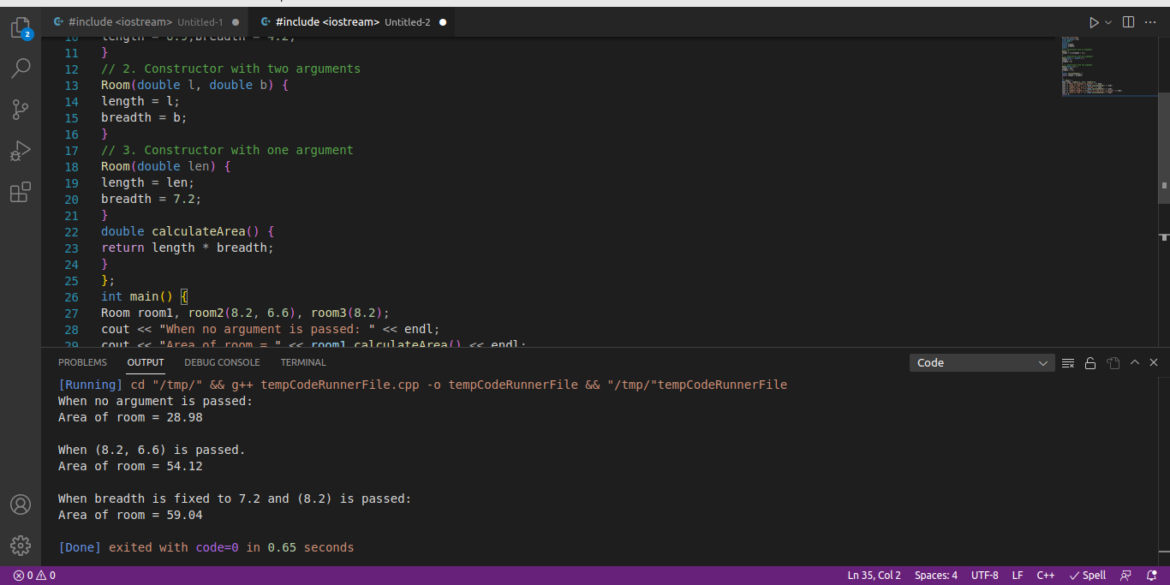
Review Questions

Question # 01

Solve all lab exercise questions and verify the output by your lab instructor??

Answer

All done
Question # 02

Show the output of a program to print the names of students by creating a Student class. If no
name is passed while creating an object of the Student class, then the name should be
"Unknown", otherwise the name should be equal to the String value passed while creating the
object of the Student class.??

Answer

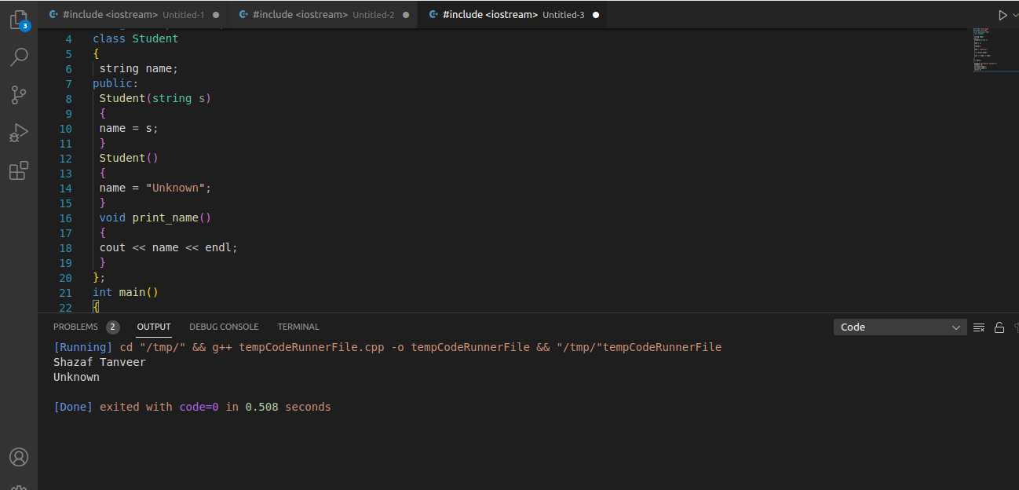
Question # 03

Create a class named 'Rectangle' with two data members- length and breadth and a function
to calculate the area which is 'length*breadth'. The class has three constructors which are :
1 - having no parameter - values of both length and breadth are assigned zero.
2 - having two numbers as parameters - the two numbers are assigned as length and breadth
respectively.
3 - having one number as parameter - both length and breadth are assigned that number.
Now, create objects of the 'Rectangle' class having none, one and two parameters and print
their areas.??

Answer
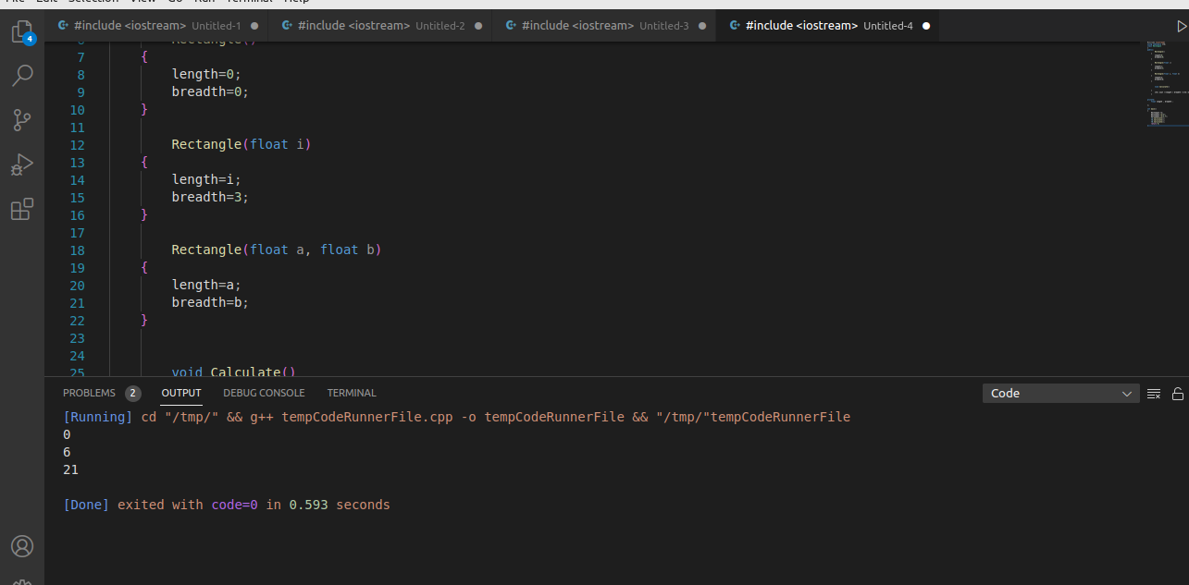

Question # 04

Create a class 'Student' with three data members which are name, age and address. The
constructor of the class assigns default values to name as "unknown", age as '0' and address
as "not available". It has two functions with the same name 'set Info'. First function has two
parameters for name and age and assigns the same whereas the second function takes has
three parameters which are assigned to name, age and address respectively. Print the name,
age and address of 10 students.
Hint - Use array of objects.??

Answer

